**Types of attributes:**

This is the initial phase of data preprocessing involves categorizing attributes into different types, which serves as a foundation for subsequent data processing steps. Attributes can be broadly classified into two main types:

1. Qualitative (Nominal (N), Ordinal (O), Binary(B)).
2. Quantitative (Numeric, Discrete, Continuous)

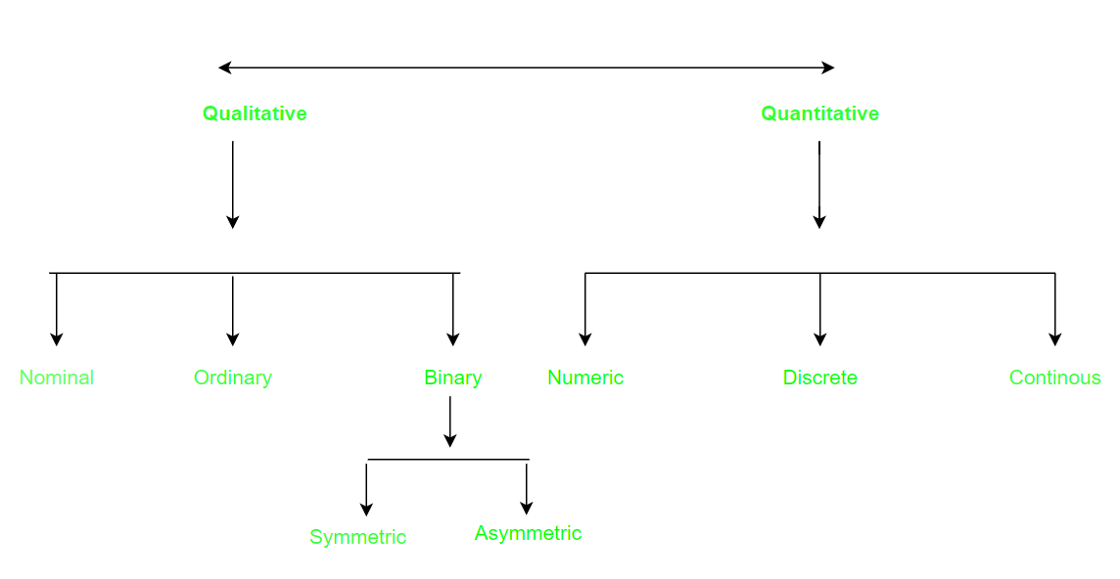

**Qualitative Attributes:**

**1. Nominal Attributes :**

Nominal attributes, as related to names, refer to categorical data where the values represent different categories or labels without any inherent order or ranking. These attributes are often used to represent names or labels associated with objects, entities, or concepts.

**Example :**

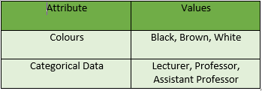

**2. Binary Attributes:** Binary attributes are a type of qualitative attribute where the data can take on only two distinct values or states. These attributes are often used to represent yes/no, presence/absence, or true/false conditions within a dataset. They are particularly useful for representing categorical data where there are only two possible outcomes. For instance, in a medical study, a binary attribute could represent whether a patient is affected or unaffected by a particular condition.

* **Symmetric:** In a symmetric attribute, both values or states are considered equally important or interchangeable. For example, in the attribute “Gender” with values “Male” and “Female,” neither value holds precedence over the other, and they are considered equally significant for analysis purposes.

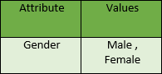

* **Asymmetric:** An asymmetric attribute indicates that the two values or states are not equally important or interchangeable. For instance, in the attribute “Result” with values “Pass” and “Fail,” the states are not of equal importance; passing may hold greater significance than failing in certain contexts, such as academic grading or certification exams

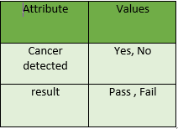

**3. Ordinal Attributes :**Ordinal attributes are a type of qualitative attribute where the values possess a meaningful order or ranking, but the magnitude between values is not precisely quantified. In other words, while the order of values indicates their relative importance or precedence, the numerical difference between them is not standardized or known.

Example:

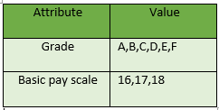

**Quantitative Attributes:**

**1. Numeric:** A numeric attribute is quantitative because, it is a measurable quantity, represented in integer or real values. Numerical attributes are of 2 types: **interval**, and **ratio-scaled.**

* An **interval-scaled** attribute has values, whose differences are interpretable, but the numerical attributes do not have the correct reference point, or we can call zero points. Data can be added and subtracted at an interval scale but can not be multiplied or divided. Consider an example of temperature in degrees Centigrade. If a day’s temperature of one day is twice of the other day we cannot say that one day is twice as hot as another day.
* A**ratio-scaled** attribute is a numeric attribute with a fix zero-point. If a measurement is ratio-scaled, we can say of a value as being a multiple (or ratio) of another value. The values are ordered, and we can also compute the difference between values, and the mean, median, mode, Quantile-range, and Five number summary can be given.

**2. Discrete :**Discrete data refer to information that can take on specific, separate values rather than a continuous range. These values are often distinct and separate from one another, and they can be either numerical or categorical in nature.  
 **Example:**

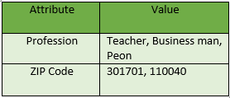

**3. Continuous**: Continuous data, unlike discrete data, can take on an infinite number of possible values within a given range. It is characterized by being able to assume any value within a specified interval, often including fractional or decimal values.

**Example :**

